ICOR 2025 Authors Guides, Paper Title

1 or 2 Lines, Times New Roman (TNR) 14 Bold

First Author, Second Author, ...... ∗(TNR 12 Bold)
1. First Author Affiliation
2. Second Author Affiliation
3. Third Author…(TNR 10 Bold). The presenting author's name must be underlined.

Abstract
The Abstract must be maximum 150 words, written with Times New Roman font (TNR) size 9. It must be 14 cm wide (3.5 cm from each side of the paper), centered in the page, Starting 10 cm from the top of the paper. Abstract, abstract, abstract, abstract. Abstract, abstract, abstract, abstract. Abstract, abstract, abstract, abstract. Abstract, abstract, abstract, abstract. Abstract, abstract, abstract, abstract. Abstract, abstract, abstract, abstract. Abstract, abstract, abstract, abstract. Abstract, abstract, abstract, abstract. Abstract, abstract, abstract, abstract. Abstract, abstract, abstract, abstract. Abstract, abstract, abstract. abstract, abstract, abstract, abstract,
abstract. Abstract, abstract, abstract, abstract. Abstract, abstract, abstract. abstract, abstract, abstract, abstract,
abstract. Abstract, abstract, abstract, abstract. Abstract, abstract, abstract. abstract, abstract, abstract, abstract,
abstract. Abstract, abstract, abstract, abstract. Abstract, abstract, abstract. abstract, abstract, abstract, abstract,

Keywords: 5 Keywords, Separated by - (TNR 10 Bold).

Author's Instruction
Use Microsoft Word in Windows to make it easier for us when applying minor changes or preparing the proceedings of the conference.
To save time and effort, only papers prepared according to this guide will be reviewed.
The paper must be included:

- Introduction
- Experimental/Theoretical
- Results and Discussion
- Conclusion
- Acknowledgement (optional)
- References

Font
The font of the text is Times New Roman. The body of the paper is size 10 and the headings are size 12 bold.

Paper size, Borders and Spaces
All submitted papers must be prepared using this template. The body of the paper consists of two columns each 7.5 cm wide, spaced 1 cm apart. The bottom of the columns is 3 cm from the paper bottom edge in all pages for A4 paper. Text should be typed single-spaced. Leave one line space between headings and the end of previous section.

Number of Pages
Papers are limited to a maximum of 2 pages including figures, graphs and tables.

Important

File size is limited to 3 Megabyte. Reduce the size of images, graphs etc. if your file size exceeds this limit.

Equations
All equations must be numbered sequentially from 1. Equation numbers must be right justified written in parenthesis. Equations must be written as follows.
$2wy+5x^{2}=\text{Sin}α$ (1)

For long equations, number is placed in the middle.

$\begin{aligned}\text{ax}+{\text{bx}}^{2}+{\text{cx}}^{3}+(d−e−f)y−\text{gz} \\ 2(\text{ab}−\text{cd})t=\text{Sin}wt\end{aligned}$ (2)

Units and Tables
Acceptable system of units is standard metric (SI). Table titles must be justified on the top (TNR 8 bold). Within the tables, text and number must be centered in the cells. One line space must be left between end of section and table title.

Figures and Graphs
All figures and graphs must be placed at the end of the paper. They should all be numbered and have a

title. Only figures, which are referred to, should be included in the paper.
Figures are centered in the column, with a title justified at the bottom (TNR 8 bold). Leave one line space between figures, and also between figures and bottom of the text.

References
References must be listed as they are referred to in the text. Hence, only references, which are referred to in the paper, should be included in the list.

- Keshvari H, Mirzadeh H, Mansoori P, Orang F and Khorasani MT, Iran. Polym. J., 17, 171-182, 2008.
2. Shih KY, US Patent 6,686,306, 2004.
3. Shenoy AV, Rheology of highly filled polymer systems, 1st ed, Kluwer Academic, London, 1999.
4. Goraltchouk A., Freier T., Shoichet M.S., Biomaterials, [Online], 26, 7555-7563, 2005. Available from http://lib.bioinfo.pl/pmid:16005955 (accessed Feb 2006).

Table 1. Titanium content and surface area of the catalyst. (TNR 8 bold)

Test | Catalyst | Silica
Titanium content (%) [g(Ti)/g(cat)]  Specific surface area (m²/g) | 4.01  140.6221 | 0  129

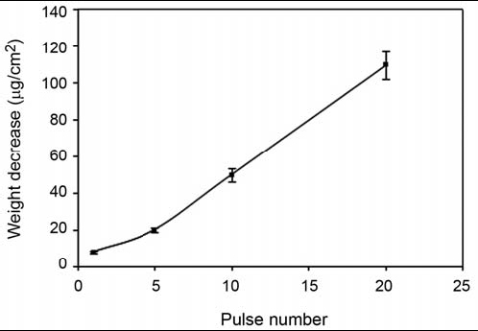

Fig 1. Weight decreases of PDMS films (μg/cm²) after irradiation by CO₂-pulsed laser with different number of pulses and fluencies; wavelength=9.58 μm, frequency = 1Hz at 0.6 J/cm². (TNR 8 bold)

Please, have nearly equal column heights at the end.

Show the corresponding author, E-mail:…..(TNR 10)

